**Concrete Strength Prediction**

**Project Report**

**Abstract**

This study presents a machine learning approach for predicting the compressive strength of concrete based on its mixture components. Using a dataset consisting of 1,030 observations, multiple regression models were evaluated, with XGBoost achieving the highest predictive performance (R² score of 0.904). The model is deployed via a web app to provide an intuitive interface for predicting concrete strength. The findings from this model offer significant value for civil engineers and construction companies, optimizing concrete mixtures for specific strength requirements.

**1. Introduction**

Concrete is one of the most important materials in the construction industry due to its versatility and strength. Predicting its compressive strength is crucial for ensuring the safety and durability of structures. Traditional methods for determining strength involve experimental approaches that can be time-consuming and costly. This study aims to leverage machine learning to predict concrete strength efficiently, enabling faster and more cost-effective decision-making.

Machine learning models have shown promise in predictive tasks involving complex relationships between variables. In this work, we aim to predict concrete compressive strength based on its constituent components, such as cement, water, and aggregates, using advanced regression models.

**2. Literature Review**

Several studies have explored the use of machine learning for predicting concrete properties. Yeh (1998) first introduced the dataset used in this study and demonstrated the effectiveness of neural networks in concrete strength prediction. Recent studies have applied various regression techniques, including Random Forest, Support Vector Regression, and XGBoost, showing their ability to model complex interactions between ingredients.

**2. Dataset Overview**

**Dataset Goal**

The goal is to predict the compressive strength of concrete based on its various ingredients and age. This prediction helps civil engineers and construction companies optimize concrete mixtures to meet strength specifications.

**Features:**

The dataset contains 1030 observations and 9 attributes:

* **Input Variables:**
  1. **Cement** (kg/m³)
  2. **Blast Furnace Slag** (kg/m³)
  3. **Fly Ash** (kg/m³)
  4. **Water** (kg/m³)
  5. **Superplasticizer** (kg/m³)
  6. **Coarse Aggregate** (kg/m³)
  7. **Fine Aggregate** (kg/m³)
  8. **Age** (days)
* **Target Variable:** 9. **Concrete compressive strength** (MPa)

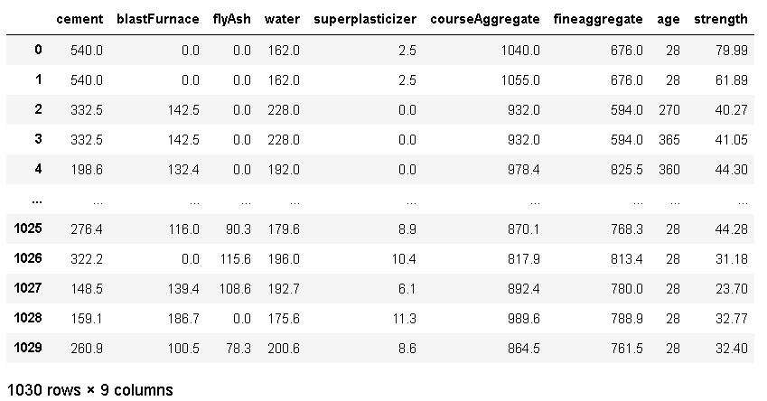

**Data Characteristics:**

* Multivariate regression problem.
* Data is raw and unscaled.
* There are no missing values in the dataset.

**Dataset Source:**

The original dataset was created by **Prof. I-Cheng Yeh** and has been used in multiple studies related to concrete strength prediction​

Link for the Dataset - [*https://www.kaggle.com/datasets/elikplim/concrete-compressive-strength-data-set*](https://www.kaggle.com/datasets/elikplim/concrete-compressive-strength-data-set)

**3. Model Selection and Development**

**Modeling Approach:**

Several machine learning models were evaluated:

1. **Linear Regression**
2. **Ridge Regression**
3. **Lasso Regression**
4. **Random Forest Regression**
5. **XGBoost Regression**

After evaluating the models based on the R2R^2R2 score, **XGBoost** was selected due to its highest score of **0.904**.

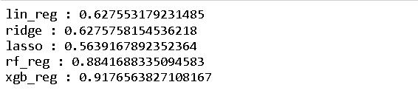

**Data Preprocessing:**

* **Scaling**: Features were standardized using StandardScaler to ensure that each feature has the same scale, preventing any dominance by one feature.
* **Train-Test Split**: The data was split into training and testing sets in an 80:20 ratio.



**Graphs and Visualization:**

* Correlation Analysis

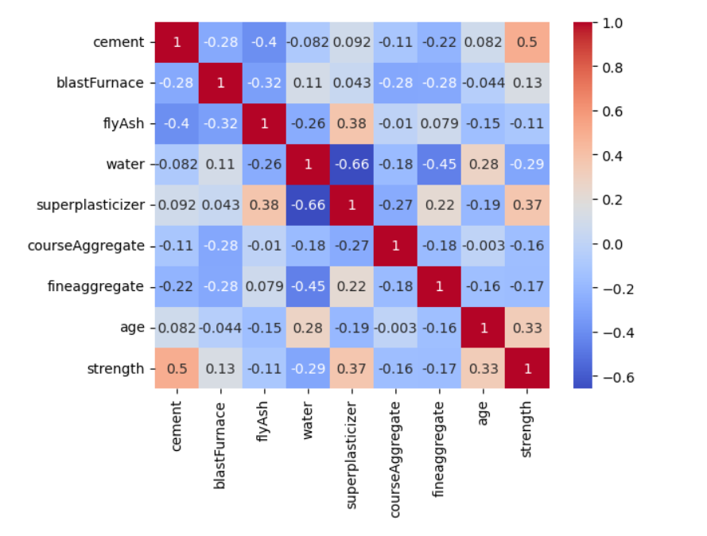

* **Feature Importance:**

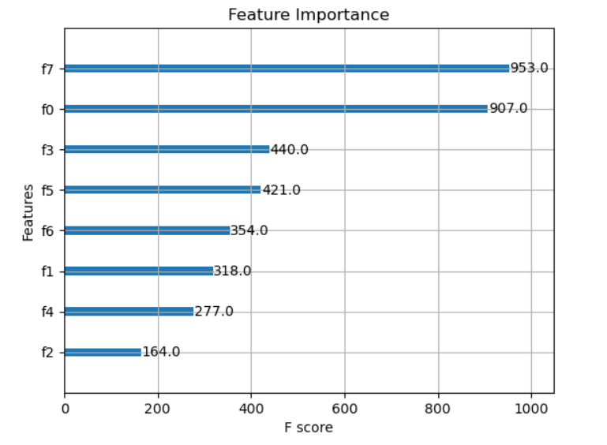

* **Scatter Plot:**

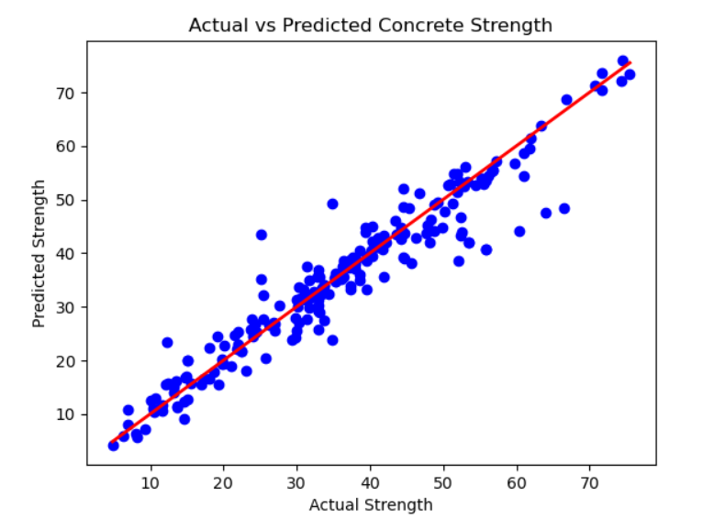

**4. Project Structure**

**Files:**

* app.py: Main script for the Streamlit app.
* conc.csv: Dataset file containing concrete mixture data and corresponding strength.

**Libraries Used:**

* streamlit: For creating the web interface.
* pandas: For dataset handling and manipulation.
* numpy: For numerical computations.
* scikit-learn: For preprocessing and evaluation metrics.
* xgboost: For building and training the predictive model.

**5. Application Usage**

**How to Run the App:**

1. **Install Required Libraries**: Ensure you have all the necessary Python packages installed. You can install them via:

**pip install streamlit pandas numpy scikit-learn xgboost**

1. **Run the Streamlit App**: Execute the following command to start the app:



1. **Interacting with the App**:
   * The app interface will open in your browser.
   * You will be asked to enter values for each of the 8 input features: Cement, Water, etc.
   * After entering the values, click on the **"Predict Strength"** button to get the predicted compressive strength of the concrete.

**Example Inputs:**

- Cement: 150.0 kg/m³

- Water: 200.0 kg/m³

- Age: 28 days

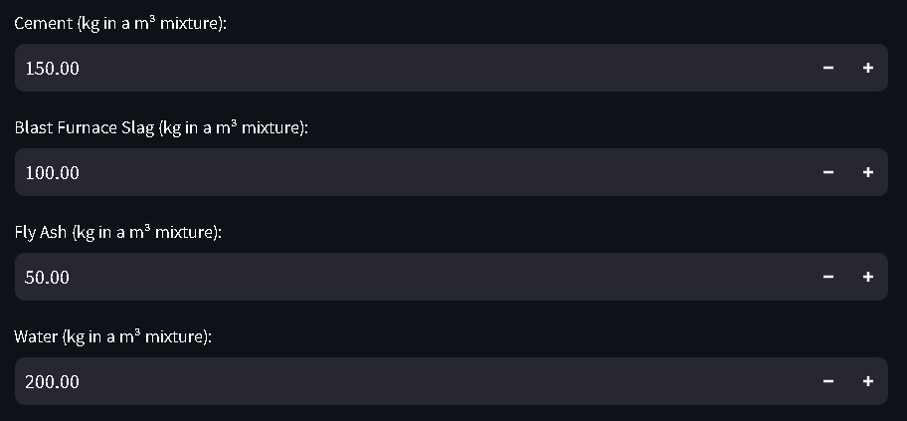

**Output:**

The app will predict the compressive strength of concrete in **megapascals (MPa)**, such as:

Predicted Concrete Strength: 19.72 MPa



**6. Model Details**

**Model Training:**

* **Model**: XGBRegressor()
* **Objective**: Predict the compressive strength of concrete.
* **Hyperparameters**: Default settings were used, and additional tuning can be done for improved performance.

**Model Evaluation:**

The XGBoost model was evaluated using the test set, achieving an R2R^2R2 score of **0.904**.

**7. Frontend and Backend Code**

**Frontend (Streamlit):**

The frontend is built using Streamlit, which provides an easy-to-use interface for users to input concrete mixture data and get predictions.

**Backend (XGBoost Model):**

The backend consists of the XGBoost model trained on the dataset. The model takes the input data, scales it, and provides the predicted compressive strength.

**8. Future Work**

Future improvements to this study could include:

* **Incorporating environmental factors**: Variables such as ambient temperature and humidity could improve the accuracy of strength predictions.
* **Model optimization**: Hyperparameter tuning of the XGBoost model and experimenting with other advanced models, such as Neural Networks, could yield even better performance.
* **Deployment improvements**: Hosting the web app on a cloud platform like AWS or Heroku for broader accessibility.

**9. Conclusion**

This project demonstrates the ability to predict concrete compressive strength using machine learning, particularly leveraging **XGBoost** for high performance. The web app provides a user-friendly interface for civil engineers or construction professionals to input concrete mixture data and receive accurate strength predictions, helping in optimizing the design of concrete structures.

**10. References**

* Yeh, I. C. (1998). Modeling of strength of high-performance concrete using artificial neural networks. *Cement and Concrete Research*, 28(12), 1797-1808.
* Dataset: Yeh, I-Cheng, Concrete Compressive Strength, available at [Kaggle](https://www.kaggle.com/)